1. **SET UP JDBC ENVIRONMENT-**

* Eclipse IDE for Enterprise Java Developers
* Apache Tomcat Server
* JRE: OpenJDK Runtime Environment
* MySQL Connector for Java

Adding the jar files for MySQL connection for Java

* **mysql-connector-java.jar** is already present in your lab. (Refer the QA to QE : Lab guide - Phase 1)
* Take **mysql-connector-java.jar** file from the folder mentioned in the lab guide for phase 1 and add it to the project’s **WebContent/WEB-INF/lib** folder
* Before building the project, we need to confirm that **servlet-api.jar** has been added to the project.
* In the Project Explorer, right click on **JDBCSetup** and choose **Properties.**
* Select **Java Build Path** from the options on the left.
* Click on **Libraries** tab on the right.
* Under **ClassPath,** expand the node that says **Apache Tomcat.**
* If there is an existing entry for **servlet-api.jar,** then click on **Cancel** and exit the window.
* If it is not there, then click on **Classpath**entry and click on **Add External JARs** button on the right.
* From the **file** list, select **servlet-api.jar** file and click on **Ok.**
* Click on **Apply and Close.**

**2) Demonstrate Connection, statement and result:-**

**Step 3.2.1:** Creating a database in MySQL and creating a table in it

* MySQL is already installed in your practice lab. (Refer QA to QE: Lab Guide - Phase 1)
* Log in to the MySQL command line console
* Type **CREATE DATABASE ecommerce** and press **Enter**
* Type **USE ecommerce** and press **Enter**
* Type **CREATE TABLE eproduct (ID bigint primary key auto_increment, name varchar(100), price decimal(10,2), date_added timestamp default now())** and press **Enter**
* We will now add some rows to the table
* Type **INSERT INTO eproduct(name, ‘HP Laptop ABC’, 12000)** and press **Enter**
* Type **INSERT INTO eproduct(name, ‘Acer Laptop ABC’, 14000)** and press **Enter**
* Type **INSERT INTO eproduct(name, ‘Lenovo Laptop ABC’, 12000)** and press **Enter**
* Type **SELECT * from eproduct**and press **Enter** to confirm that the rows have been added
* Type **EXIT** to exit the MySQL command console

**Step 3.2.2:** Creating a dynamic web project

* Open Eclipse
* Go to the **File** menu. Choose **New->Dynamic Web Project**
* Enter the project name as **JDBCSetup**. Click on **Next**
* Enter nothing in the next screen and click on **Next**
* Check the checkbox **Generate web.xml deployment descriptor** and click on **Finish**
* This will create the project files in the Project Explorer

**Step 3.2.3:** Adding the jar files for MySQL Connection for Java

* **mysql-connector-java.jar** is already present in your lab. To learn about its directory path details you can refer the **lab guide for phase 1**
* Take **mysql-connector-java.jar** file from the folder mentioned in the lab guide for phase 1 and add it to the project’s **WebContent/WEB-INF/lib** folder

**Step 3.2.4:** Creating an HTML page index.html

* In the Project Explorer, expand the project **JDBCSetup**
* Expand **WebContent**. Right click on **WebContent**. Choose **New->HTML File**
* Enter the filename as index.html and click on **Finish**
* Enter the following code:

<!DOCTYPE html>

<**html**>

<**head**>

<**meta** charset="UTF-8">

<**title**>JDBC Statements and Resultsets</**title**>

</**head**>

<**body**>

<**a**href="list">Product Info</**a**><**br**>

</**body**>

</**html**>

* Click on the **Save** icon

**Step 3.2.5:** Creating a DBConnection class to initiate a JDBC connection in code

* In the Project Explorer, expand **JDBCSetup->Java Resources**
* Right click on **src** and choose **New->Class**
* In **Package**, enter com.ecommerceand in **Name** enter DBConnectionand click on **Finish**
* Enter the following code:

**package**com.ecommerce;

**import**java.sql.Connection;

**import**java.sql.DriverManager;

**import**java.sql.SQLException;

**publicclass**DBConnection{

**privateConnection**connection;

**public**DBConnection(**String**dbURL,**String** user,**String**pwd)**throwsClassNotFoundException**,**SQLException**{

**Class**.forName("com.mysql.jdbc.Driver");

**this**.connection=**DriverManager**.getConnection(dbURL, user,pwd);

}

**publicConnection**getConnection(){

**returnthis**.connection;

}

**public**voidcloseConnection()**throwsSQLException**{

**if**(**this**.connection!=**null**)

**this**.connection.close();

}

}

**Step 3.2.6:** Creating a config.properties file to storeJDBCcredentials

* In the Project Explorer, expand the project **JDBCSetup**
* Expand **WebContent**. Right click on **WebContent**. Choose **New->File**
* Enter the filename as config.properties and click on **Finish**
* Enter the following data:

url=jdbc:mysql://localhost:3306/ecommerce

userid=root

password=master

**Step 3.2.7:** Creating a ProductDetails servlet

* In the Project Explorer, expand **JDBCSetup->Java Resources**
* Right click on **src** and choose **New->Servlet**
* In **Class Name,** enter **ProductDetails** and click on **Finish**
* Enter the following code:

**import**java.io.IOException;

**import**java.io.InputStream;

**import**java.io.PrintWriter;

**import**java.math.BigDecimal;

**import**java.sql.CallableStatement;

**import**java.sql.ResultSet;

**import**java.sql.SQLException;

**import**java.sql.Statement;

**import**java.util.Properties;

**import**javax.servlet.ServletException;

**import**javax.servlet.annotation.WebServlet;

**import**javax.servlet.http.HttpServlet;

**import**javax.servlet.http.HttpServletRequest;

**import**javax.servlet.http.HttpServletResponse;

**import**com.ecommerce.DBConnection;

/**

**\*** Servlet implementation class ProductDetails

*/

**@WebServlet("/ProductDetails")**

**publicclass**ProductDetails**extends**HttpServlet{

**privatestaticfinal**longserialVersionUID=1L;

/**

**\*@see**HttpServlet**#**HttpServlet()

*/

**public**ProductDetails(){

**super**();

// TODO Auto-generated constructor stub

}

/**

**\*@see**HttpServlet**#**doGet(HttpServletRequest request**,**HttpServletResponse response)

*/

**protected**voiddoGet(HttpServletRequest request,HttpServletResponse response)**throws**ServletException,**IOException**{

// TODO Auto-generated method stub

**try**{

**PrintWriter** out =response.getWriter();

out.println("<html><body>");

**InputStream** in = getServletContext().getResourceAsStream("/WEB-INF/config.properties");

**Properties** props =**newProperties**();

props.load(in);

DBConnection conn =**new**DBConnection(props.getProperty("url"),props.getProperty("userid"),props.getProperty("password"));

**Statement**stmt=conn.getConnection().createStatement(**ResultSet**.TYPE_SCROLL_INSENSITIVE,**ResultSet**.CONCUR_READ_ONLY);

stmt.executeUpdate("insert into eproduct (name, price, date_added) values ('New Product', 17800.00, now())");

**ResultSet**rst=stmt.executeQuery("select * from eproduct");

**while**(rst.next()){

out.println(rst.getInt("ID")+", "+rst.getString("name")+"<Br>");

}

stmt.close();

out.println("</body></html>");

conn.closeConnection();

}**catch**(**ClassNotFoundException** e){

e.printStackTrace();

}**catch**(**SQLException** e){

e.printStackTrace();

}

}

/**

**\*@see**HttpServlet**#**doPost(HttpServletRequest request**,**HttpServletResponse response)

*/

**protected**voiddoPost(HttpServletRequest request,HttpServletResponse response)**throws**ServletException,**IOException**{

// TODO Auto-generated method stub

doGet(request, response);

}

}

**Step 3.2.8:** Configuring web.xml

* In the Project Explorer, expand **JDBCSetup->WebContent->WEB-INF**
* Double click on **web.xml** to open it in the editor
* Enter the following script:

<?xml version="1.0" encoding="UTF-8"?>

<web-appxmlns:xsi="http://www.w3.org/2001/XMLSchema-instance"xmlns="http://xmlns.jcp.org/xml/ns/javaee"xsi:schemaLocation="http://xmlns.jcp.org/xml/ns/javaee http://xmlns.jcp.org/xml/ns/javaee/web-app_4_0.xsd" id="WebApp_ID" version="4.0">

<display-name>JDBC Statements and Resultsets</display-name>

<welcome-file-list>

<welcome-file>index.html</welcome-file>

<welcome-file>index.htm</welcome-file>

<welcome-file>index.jsp</welcome-file>

<welcome-file>default.html</welcome-file>

<welcome-file>default.htm</welcome-file>

<welcome-file>default.jsp</welcome-file>

</welcome-file-list>

<servlet>

<servlet-name>ProductDetails</servlet-name>

<servlet-class>ProductDetails</servlet-class>

</servlet>

<servlet-mapping>

<servlet-name>ProductDetails</servlet-name>

<url-pattern>/list</url-pattern>

</servlet-mapping>

</web-app>

**Step 3.2.9:** Checking for servlet-api.jar

* Before building the project, we need to confirm that **servlet-api.jar** has been added to the project
* In the Project Explorer, right click on **JDBCSetup** and choose **Properties**
* Select **Java Build Path** from the options on the left
* Click on **Libraries** tab on the right
* Under **ClassPath,** expand the node that says **Apache Tomcat**
* If there is an existing entry for **servlet-api.jar,** then click on **Cancel** and exit the window
* If it is not there, then click on **Classpath**entry and click on **Add External JARs** button on the right
* From the **file** list, select **servlet-api.jar** file and click on **Ok**
* Click on **Apply and Close**

**Step 3.2.10:** Building the project

* From the **Project** menu at the top, click on **Build**
* If any compile errors are shown, fix them as required

**Step 3.2.11:** Publishing and starting the project

* If you do not see the **Servers** tab near the bottom of the IDE, go to the **Window** menu and click on **Show View->Servers**
* Right click the **Server** entry and choose **Add and Remove**
* Click the **Add** button to move **JDBCSetup** from the **Available** list to the **Configured**list
* Click on **Finish**
* Right click the **Server** entry and click on **Publish**
* Right click the **Server** entry and click on **Start**
* This will start the server

**Step 3.2.12:** Running the project

* To run the project, open a web browser and type: [**http://localhost:8080/**](http://localhost:8080/ServletConcept)**JDBCSetup**

**Step 3.2.13:** Pushing the code to your GitHub repositories

Open your command prompt and navigate to the folder where you have created your files

cd <folder path>

Initialize your repository using the following command:

git init

Add all the files to your git repository using the following command:

git add .

Commit the changes using the following command:

git commit . -m “Changes have been committed.”

Push the files to the folder you initially created using the following command:

git push -u origin master

**3)- Demonstrate how to create, select, and drop a database in JDBC.**

To create data-

package myPackage;

import java.sql.Connection;

import java.sql.DriverManager;

import java.sql.Statement;

import java.sql.ResultSet;

public class Student {

public void createdabase () {

}

public void createtable() {

}

public void createData() {

try {

String url = "jdbc:mysql://localhost:3306/";

String db = "db";

String userName = "root";

String password = "Sagar@9871";

Connection conn = DriverManager.getConnection(url+db,userName,password);

Statement stm = conn.createStatement();

String query = "INSERT INTO student(sid, sname, semail) Values(2,'sagar','sagarkonkati73@gmail.com')";

stm.execute(query);

System.out.println("data created sucessfully");

conn.close();

} catch (Exception e) {

e.printStackTrace();

}

**4) Demonstrate how to create, select, and drop a database in JDBC**

public class Student {

public void createdabase () {

}

public void createtable() {

}

public void createData() {

try {

String url = "jdbc:mysql://localhost:3306/";

String db = "db";

String userName = "root";

String password = "Sagar@9871";

Connection conn = DriverManager.getConnection(url+db,userName,password);

Statement stm = conn.createStatement();

String query = "INSERT INTO student(sid, sname, semail) Values(2,'sagar','sagarkonkati73@gmail.com')";

stm.execute(query);

System.out.println("data created sucessfully");

conn.close();

} catch (Exception e) {

e.printStackTrace();

}

}

public void readData() {

try {

String url = "jdbc:mysql://localhost:3306/";

String db = "db";

String userName = "root";

String password = "Sagar@9871";

Connection conn = DriverManager.getConnection(url+db,userName,password);

Statement stm = conn.createStatement();

String query = "select * from student";

ResultSetrs = stm.executeQuery(query);

while (rs.next()) {

System.out.println("id = " +rs.getInt(1));

System.out.println(" sname = "+rs.getString(2));

System.out.println("semail ="+rs.getString(3));

}

System.out.println("data created sucessfully");

conn.close();

} catch (Exception e) {

e.printStackTrace();

}

}

public void updateData() {

try {

String url = "jdbc:mysql://localhost:3306/";

String db = "db";

String userName = "root";

String password = " Sagar@9871";

Connection conn = DriverManager.getConnection(url+db,userName,password);

Statement stm = conn.createStatement();

String query = "UPDATE student SET sname = 'Dhoni' WHERE sid = 2";

stm.execute(query);

System.out.println("data Updated sucessfully");

conn.close();

} catch (Exception e) {

e.printStackTrace();

}

}

public void alterdata() {

try {

String url = "jdbc:mysql://localhost:3306/";

String db = "db";

String userName = "root";

String password = " Sagar@9871";

Connection conn = DriverManager.getConnection(url+db,userName,password);

Statement stm = conn.createStatement();

String query = "ALTER TABLE student ADD CONSTRAINT PK_student_sid PRIMARY KEY (sid)";

stm.execute(query);

System.out.println("data Altered sucessfully");

conn.close();

} catch (Exception e) {

e.printStackTrace();

}

}

public void deleteData() {

try {

String url = "jdbc:mysql://localhost:3306/";

String db = "db";

String userName = "root";

String password = " Sagar@9871";

Connection conn = DriverManager.getConnection(url+db,userName,password);

Statement stm = conn.createStatement();

String query = "DELETE FROM student WHERE sname = 'Dhoni'";

stm.execute(query);

System.out.println("data Deleted sucessfully");

conn.close();

} catch (Exception e) {

e.printStackTrace();

}

5) **Demonstrate database record handling using JDBC.**

Creating a database in MySQL and a table in it

* MySQL is already installed in your practice lab,\ (Refer QA to QE: Lab Guide - Phase 1)
* Log in to the MySQL command line console
* Type **CREATE DATABASE ecommerce** and press **Enter**
* Type **USE ecommerce** and press **Enter**
* Type **CREATE TABLE eproduct (ID bigint primary key auto_increment, name varchar(100), price decimal(10,2), date_added timestamp default now())** and press **Enter**
* We will now add some rows into the table
* Type **INSERT INTO eproduct(name, ‘HP Laptop ABC’, 12000)** and press **Enter**
* Type **INSERT INTO eproduct(name, ‘Acer Laptop ABC’, 14000)** and press **Enter**
* Type **INSERT INTO eproduct(name, ‘Lenovo Laptop ABC’, 12000)** and press **Enter**
* Type **SELECT * from eproduct**and press **Enter** to confirm that the rows have been added
* Type **EXIT** to exit the MySQL command console

**Step 3.5.2:** Creating a dynamic web project

* Open Eclipse
* Go to the **File** menu. Choose **New->Dynamic Web Project**
* Enter the project name as **JDBCSetup**. Click on **Next**
* Enter nothing in the next screen and click on **Next**
* Check the checkbox **Generate web.xml deployment descriptor** and click on **Finish**
* This will create the project files in the Project Explorer

**Step 3.5.3:** Adding the jar files for MySQL connection for Java

* **mysql-connector-java.jar** is already present in your lab. To learn about its directory path details you can refer the **lab guide for phase 1**
* Take **mysql-connector-java.jar** file from the folder mentioned in the lab guide for phase 1 and add it to the project’s **WebContent/WEB-INF/lib** folder

**Step 3.5.4:** Creating an HTML page index.html

* In the Project Explorer, expand the project **JDBCSetup**
* Expand **WebContent**. Right click on **WebContent**. Choose **New->HTML File**
* Enter the filename as **index.html** and click on **Finish**
* Enter the following code:

<!DOCTYPE html>

<**html**>

<**head**>

<**meta** charset="UTF-8">

<**title**>JDBC Insert, Update, Delete</**title**>

</**head**>

<**body**>

<**a**href="list">Product Info</**a**><**br**>

</**body**>

</**html**>

* Click on the **Save** icon

**Step 3.5.5:** Creating a DBConnection class to initiate a JDBC connection in code

* In the Project Explorer, expand **JDBCSetup->Java Resources**
* Right click on **src** and choose **New->Class**
* In **Package,** enter **com.ecommerce**and in **Name** enter **DBConnection**and click on **Finish**
* Enter the following code:

**package**com.ecommerce;

**import**java.sql.Connection;

**import**java.sql.DriverManager;

**import**java.sql.SQLException;

**publicclass**DBConnection{

**privateConnection**connection;

**public**DBConnection(**String**dbURL,**String** user,**String**pwd)**throwsClassNotFoundException**,**SQLException**{

**Class**.forName("com.mysql.jdbc.Driver");

**this**.connection=**DriverManager**.getConnection(dbURL, user,pwd);

}

**publicConnection**getConnection(){

**returnthis**.connection;

}

**public**voidcloseConnection()**throwsSQLException**{

**if**(**this**.connection!=**null**)

**this**.connection.close();

}

}

**Step 3.5.6:** Creating a config.properties file to store JDBC credentials

* In the Project Explorer, expand the project **JDBCSetup**
* Expand **WebContent**. Right click on **WebContent**. Choose **New->File**
* Enter the filename as **config.properties** and click on **Finish**
* Enter the following data:

url=jdbc:mysql://localhost:3306/ecommerce

userid=root

password=master

**Step 3.5.7:** Creating a ProductDetails servlet

* In the Project Explorer, expand **JDBCSetup->Java Resources**
* Right click on **src** and choose **New->Servlet**
* In **Class Name,** enter **ProductDetails** and click on **Finish**
* Enter the following code:

**import**java.io.IOException;

**import**java.io.InputStream;

**import**java.io.PrintWriter;

**import**java.math.BigDecimal;

**import**java.sql.CallableStatement;

**import**java.sql.ResultSet;

**import**java.sql.SQLException;

**import**java.sql.Statement;

**import**java.util.Properties;

**import**javax.servlet.ServletException;

**import**javax.servlet.annotation.WebServlet;

**import**javax.servlet.http.HttpServlet;

**import**javax.servlet.http.HttpServletRequest;

**import**javax.servlet.http.HttpServletResponse;

**import**com.ecommerce.DBConnection;

/**

**\*** Servlet implementation class ProductDetails

*/

**@WebServlet("/ProductDetails")**

**publicclass**ProductDetails**extends**HttpServlet{

**privatestaticfinal**longserialVersionUID=1L;

/**

**\*@see**HttpServlet**#**HttpServlet()

*/

**public**ProductDetails(){

**super**();

// TODO Auto-generated constructor stub

}

/**

**\*@see**HttpServlet**#**doGet(HttpServletRequest request**,**HttpServletResponse response)

*/

**protected**voiddoGet(HttpServletRequest request,HttpServletResponse response)**throws**ServletException,**IOException**{

// TODO Auto-generated method stub

**try**{

**PrintWriter** out =response.getWriter();

out.println("<html><body>");

**InputStream** in = getServletContext().getResourceAsStream("/WEB-INF/config.properties");

**Properties** props =**newProperties**();

props.load(in);

DBConnection conn =**new**DBConnection(props.getProperty("url"),props.getProperty("userid"),props.getProperty("password"));

**Statement**stmt=conn.getConnection().createStatement(**ResultSet**.TYPE_SCROLL_INSENSITIVE,**ResultSet**.CONCUR_READ_ONLY);

stmt.executeUpdate("insert into eproduct (name, price, date_added) values ('New Product', 17800.00, now())");

out.println("Executed an insert operation<br>");

stmt.executeUpdate("update eproduct set price=2000 where name = 'New Product'");

out.println("Executed an update operation<br>");

stmt.executeUpdate("delete from eproduct where name = 'New Product'");

out.println("Executed a delete operation<br>");

stmt.close();

conn.closeConnection();

out.println("</body></html>");

conn.closeConnection();

}**catch**(**ClassNotFoundException** e){

e.printStackTrace();

}**catch**(**SQLException** e){

e.printStackTrace();

}

}

/**

**\*@see**HttpServlet**#**doPost(HttpServletRequest request**,**HttpServletResponse response)

*/

**protected**voiddoPost(HttpServletRequest request,HttpServletResponse response)**throws**ServletException,**IOException**{

// TODO Auto-generated method stub

doGet(request, response);

}

}

**Step 3.5.8:** Configuring web.xml

* In the Project Explorer, expand **JDBCSetup->WebContent->WEB-INF**
* Double click on **web.xml** to open it in the editor
* Enter the following script:

<?xml version="1.0" encoding="UTF-8"?>

<web-appxmlns:xsi="http://www.w3.org/2001/XMLSchema-instance"xmlns="http://xmlns.jcp.org/xml/ns/javaee"xsi:schemaLocation="http://xmlns.jcp.org/xml/ns/javaee http://xmlns.jcp.org/xml/ns/javaee/web-app_4_0.xsd" id="WebApp_ID" version="4.0">

<display-name>JDBC Insert, Update, Delete</display-name>

<welcome-file-list>

<welcome-file>index.html</welcome-file>

<welcome-file>index.htm</welcome-file>

<welcome-file>index.jsp</welcome-file>

<welcome-file>default.html</welcome-file>

<welcome-file>default.htm</welcome-file>

<welcome-file>default.jsp</welcome-file>

</welcome-file-list>

<servlet>

<servlet-name>ProductDetails</servlet-name>

<servlet-class>ProductDetails</servlet-class>

</servlet>

<servlet-mapping>

<servlet-name>ProductDetails</servlet-name>

<url-pattern>/list</url-pattern>

</servlet-mapping>

</web-app>

**Step 3.5.9:** Checking for servlet-api.jar

* Before building the project, we need to confirm that **servlet-api.jar** has been added to the project
* In the Project Explorer, right click on **JDBCSetup**and choose **Properties**
* Select **Java Build Path** from the options on the left
* Click on **Libraries** tab on the right
* Under **ClassPath,** expand the node that says **Apache Tomcat**
* If there is an existing entry for **servlet-api.jar,** then click on **Cancel** and exit the window
* If it is not there, then click on **Classpath**entry and click on **Add External JARs** button on the right
* From the **file** list, select **servlet-api.jar** file and click on **Ok**
* Click on **Apply and Close**

**Step 3.5.10:** Building the project

* From the **Project** menu at the top, click on **Build**
* If any compile errors are shown, fix them as required

**Step 3.5.11:** Publishing and starting the project

* If you do not see the **Servers** tab near the bottom of the IDE, go to the **Window** menu and click on **Show View->Servers**
* Right click the **Server** entry and choose **Add and Remove**
* Click the **Add** button to move **JDBCSetup** from the **Available** list to the **Configured**list
* Click on **Finish**
* Right click the **Server** entry and click on **Publish**
* Right click the **Server** entry and click on **Start**
* This will start the server

**6) Transaction Management in JDBC.**

**Step 3.6.1:** Writing a program to perform JDBC transaction management using Auto-Commit Mode.

* By default, when we create a database connection, it runs in **auto-commit** mode. It means that whenever we execute a query, the commit is fired automatically. So, every SQL query we fire is a transaction and if we are running DML or DDL queries, the changes are getting saved in the database after every SQL statement is executed .
* Sometimes we want a group of SQL queries to be part of a transaction, so that we can commit them when all the queries run successfully. If we get any exception, we have a choice to rollback all the queries executed as part of the transaction.
* Let’s understand with a simple example where we want to utilize JDBC transaction management support for data integrity. Let’s say we have “transaction_management” database and employee information saved in two tables. Example: I am using MySQL database.
* Create two tables ‘employee’ and ‘address’ in ‘transaction_management’ database using the credentials below:

**CREATETABLE**transaction_management.employee(

empIdint(11) unsigned NOTNULL,

name varchar(20) DEFAULT NULL,

**PRIMARYKEY**(`empId`)) ENGINE=InnoDB DEFAULT CHARSET=utf8;

**CREATETABLE**transaction_management.address(

empIdint(11) unsigned NOTNULL,

address varchar(20) DEFAULT NULL,

city varchar(5) DEFAULT NULL,

country varchar(20) DEFAULT NULL,

**PRIMARYKEY**(`empId`)) ENGINE=InnoDB DEFAULT CHARSET=utf8;

* OpenEclipse
* Create Java Project. Ex: JDBCTransaction
* Download “mysql-connector-java-5.1.18.jar”
* Add External jar “mysql-connector-java-5.1.18.jar” into the project

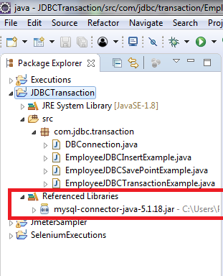

* + - Create a class called “DBConnection.java” and give the database credentials as below:
      * **DB_URL:** jdbc:mysql://localhost:3307/transaction_management
      * **DB_DRIVER_CLASS:** com.mysql.jdbc.Driver
      * **DB_USERNAME:** The username of database (here: **root)**
      * **DB_PASSWORD:** Password for the username (here: **root)**

package com.jdbc.**transaction**;

import java.sql.Connection;

import java.sql.DriverManager;

import java.sql.SQLException;

public class DBConnection {

public final static **String** DB_DRIVER_CLASS =

"com.mysql.jdbc.Driver";

public final static **String** DB_URL =

"jdbc:mysql://localhost:3307/transaction_management";

public final static **String** DB_USERNAME ="root";

public final static **String** DB_PASSWORD ="root";

public static Connection getConnection() throws

ClassNotFoundException,SQLException {

Connection con =null;

//**load** the Driver Class

Class.forName(DB_DRIVER_CLASS);

//**create** the connection **now**

con =DriverManager.getConnection(DB_URL,

DB_USERNAME, DB_PASSWORD);

System.out.println("DB Connection created

successfully");

return con;

}

}

* DBConnection is the class used by other classes for MYSQL database connection.
* Create another class called “EmployeeJDBCInsertExample.java”

**package**com.jdbc.transaction;

**import**java.sql.Connection;

**import**java.sql.PreparedStatement;

**import**java.sql.SQLException;

**publicclass**EmployeeJDBCInsertExample{

**publicstaticfinalString** INSERT_EMPLOYEE_QUERY =

"insert into Employee (empId, name) values (?,?)";

**publicstaticfinalString** INSERT_ADDRESS_QUERY ="insert into

Address (empId, address, city, country) values (?,?,?,?)";

**publicstatic**voidmain(**String**[]args){

**Connection** con =**null**;

**try**{

con =DBConnection.getConnection();

insertEmployeeData(con,1,"Pankaj");

insertAddressData

(con,1,"Albany Dr","San Jose", "USA");

}**catch**(**SQLException**|**ClassNotFoundException** e){

e.printStackTrace();

}**finally**{

**try**{

**if**(con !=**null**)

con.close();

}**catch**(**SQLException** e){

e.printStackTrace();

}

}

}

**publicstatic**voidinsertAddressData(**Connection** con,int id,

**String** address,**String** city,**String** country)**throwsSQLException**{

**PreparedStatement**stmt=

con.prepareStatement(INSERT_ADDRESS_QUERY);

stmt.setInt(1, id);

stmt.setString(2, address);

stmt.setString(3, city);

stmt.setString(4, country);

stmt.executeUpdate();

**System**.out.println("Address Data inserted successfully

for ID="+ id);

stmt.close();

}

**publicstatic**voidinsertEmployeeData(**Connection** con,int id,

**String** name) **throwsSQLException**{

**PreparedStatement**stmt=

con.prepareStatement(INSERT_EMPLOYEE_QUERY);

stmt.setInt(1, id);

stmt.setString(2, name);

stmt.executeUpdate();

**System**.out.println("Employee Data inserted

successfully for ID="+ id);

stmt.close();

}

}

* By running the “EmployeeJDBCInsertExample.java” program, we will get the following output:

DB Connection created successfully

Employee Data inserted successfully **for** ID=1

com.mysql.jdbc.MysqlDataTruncation: Data truncation: Data too

**longfor** column 'city' at row 1

at com.mysql.jdbc.MysqlIO.checkErrorPacket(MysqlIO.java:2939)

at com.mysql.jdbc.MysqlIO.sendCommand(MysqlIO.java:1623)

at com.mysql.jdbc.MysqlIO.sqlQueryDirect(MysqlIO.java:1715)

at com.mysql.jdbc.Connection.execSQL(Connection.java:3249)

at com.mysql.jdbc.PreparedStatement.executeInternal

(PreparedStatement.java:1268)

at com.mysql.jdbc.PreparedStatement.executeUpdate

(PreparedStatement.java:1541)

at com.mysql.jdbc.PreparedStatement.executeUpdate

(PreparedStatement.java:1455)

at com.mysql.jdbc.PreparedStatement.executeUpdate

(PreparedStatement.java:1440)

at com.journaldev.jdbc.transaction.EmployeeJDBCInsertExample.

insertAddressData(EmployeeJDBCInsertExample.java:45)

at com.journaldev.jdbc.transaction.EmployeeJDBCInsertExample.

**main**(EmployeeJDBCInsertExample.java:23)

* As you can see, SQLException is only raised when we are trying to insert data into the address table, because the value is bigger than the size of the column.
* If you look at the content in the employee and address tables, you will notice that data is present only in the employee table.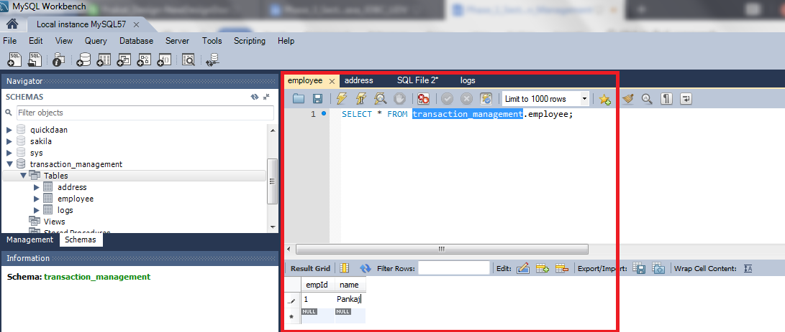

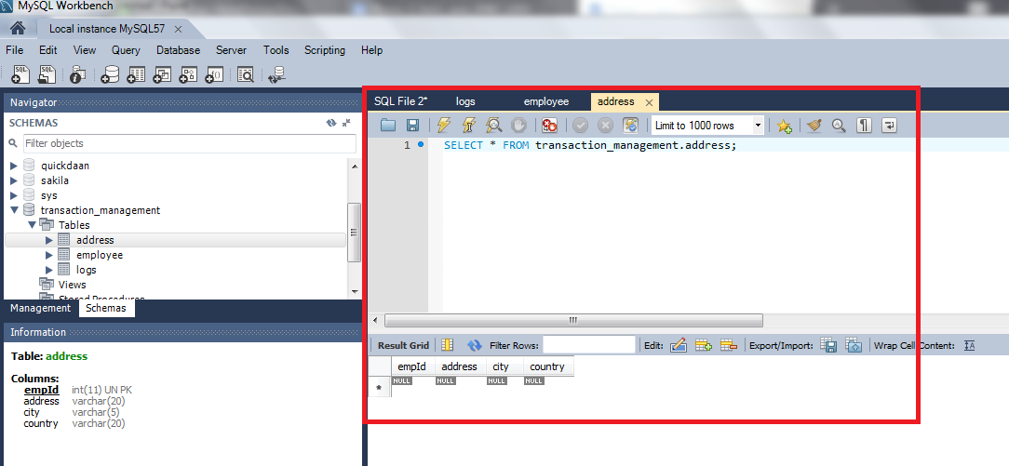

* By running the program again, it will try to insert employee information into the employee table again and will throw the below exception.

com.mysql.jdbc.exceptions.MySQLIntegrityConstraintViolationExceptio

n: Duplicate entry '1'**for** key 'PRIMARY'

at com.mysql.jdbc.SQLError.createSQLException

(SQLError.java:931)

at com.mysql.jdbc.MysqlIO.checkErrorPacket(MysqlIO.java:2941)

at com.mysql.jdbc.MysqlIO.sendCommand(MysqlIO.java:1623)

at com.mysql.jdbc.MysqlIO.sqlQueryDirect(MysqlIO.java:1715)

at com.mysql.jdbc.Connection.execSQL(Connection.java:3249)

at com.mysql.jdbc.PreparedStatement.executeInternal

(PreparedStatement.java:1268)

at com.mysql.jdbc.PreparedStatement.executeUpdate

(PreparedStatement.java:1541)

at com.mysql.jdbc.PreparedStatement.executeUpdate

(PreparedStatement.java:1455)

at com.mysql.jdbc.PreparedStatement.executeUpdate

(PreparedStatement.java:1440)

at com.journaldev.jdbc.transaction.EmployeeJDBCInsertExample.

insertEmployeeData(EmployeeJDBCInsertExample.java:57)

at com.journaldev.jdbc.transaction.EmployeeJDBCInsertExample.

**main**(EmployeeJDBCInsertExample.java:21)

* Now, there is no way we can save the data in theaddress table for the Employee. Since this program leads to data integrity issues, we need transaction management to insert data into both the tables successfully or rollback everything if any exception arises.

**Step 3.6.2:** Writing a program to perform JDBC transaction management by disabling setAutoCommit().

* JDBC API provides the method setAutoCommit() through which we can disable the auto commit feature of the connection (should disable when it’s required because the transaction will not be committed unless we call the commit() method on connection).
* Let’s write another program where we will use JDBC transaction management feature to make sure data integrity is not violated.

**package**com.jdbc.transaction;

**import**java.sql.Connection;

**import**java.sql.SQLException;

**publicclass**EmployeeJDBCTransactionExample{

**publicstatic**voidmain(**String**[]args){

**Connection** con =**null**;

**try**{

con =DBConnection.getConnection();

//set auto commit to false

con.setAutoCommit(**false**);

EmployeeJDBCInsertExample.insertEmployee

Data(con,1,"Pankaj");

EmployeeJDBCInsertExample.insertAddress

Data(con,1,"Albany Dr","San Jose","USA");

//now commit transaction

con.commit();

}**catch**(**SQLException** e){

e.printStackTrace();

**try**{

con.rollback();

**System**.out.println("JDBC

Transaction rolled back successfully");

}**catch**(**SQLException** e1){

**System**.out.println("SQLException in

rollback"+e.getMessage());

}

}**catch**(**ClassNotFoundException** e){

e.printStackTrace();

}**finally**{

**try**{

**if**(con !=**null**)

con.close();

}**catch**(**SQLException** e){

e.printStackTrace();

}

}

}

}

* Please make sure you remove the earlier inserted data from both the tables before running this program. By running this program, you will get the following output:

DB Connection created successfully

Employee Data inserted successfully **for** ID=1

com.mysql.jdbc.MysqlDataTruncation: Data truncation: Data too **long**

**for** column 'city' at row 1

at com.mysql.jdbc.MysqlIO.checkErrorPacket(MysqlIO.java:2939)

at com.mysql.jdbc.MysqlIO.sendCommand(MysqlIO.java:1623)

at com.mysql.jdbc.MysqlIO.sqlQueryDirect(MysqlIO.java:1715)

at com.mysql.jdbc.Connection.execSQL(Connection.java:3249)

at com.mysql.jdbc.PreparedStatement.executeInternal

(PreparedStatement.java:1268)

at com.mysql.jdbc.PreparedStatement.executeUpdate

(PreparedStatement.java:1541)

at com.mysql.jdbc.PreparedStatement.executeUpdate

(PreparedStatement.java:1455)

at com.mysql.jdbc.PreparedStatement.executeUpdate

(PreparedStatement.java:1440)

at com.journaldev.jdbc.transaction.EmployeeJDBCInsertExample.

insertAddressData(EmployeeJDBCInsertExample.java:45)

at com.journaldev.jdbc.transaction.EmployeeJDBCTransaction

Example.**main**(EmployeeJDBCTransactionExample.java:19)

JDBC Transaction rolled back successfully

* If you look into the database tables, you will notice that data is not inserted into both employee and address table.

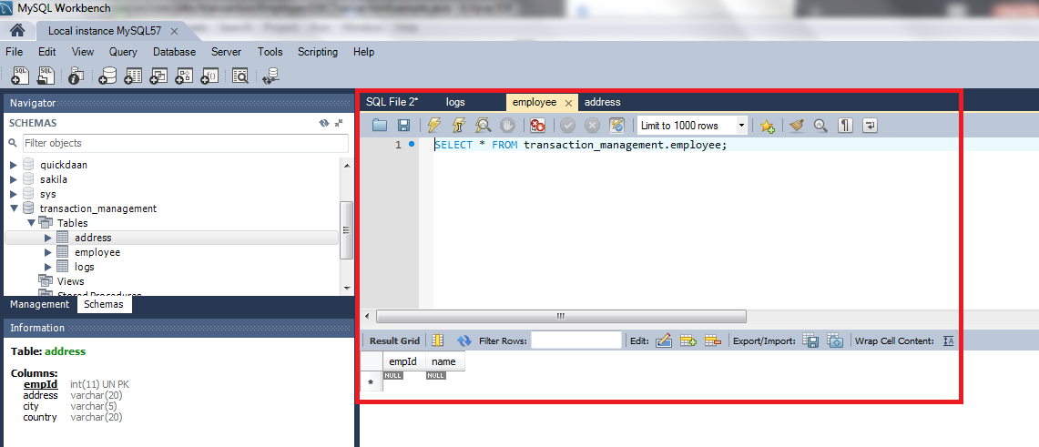



* Now we can change the city value, (here changed “San Jose” to “san” since city column size is 5) so that it can fit in the column and rerun the program to insert data into both the tables.

DB Connection created successfully

Employee Data inserted successfully **for** ID=1

Address Data inserted successfully **for** ID=1

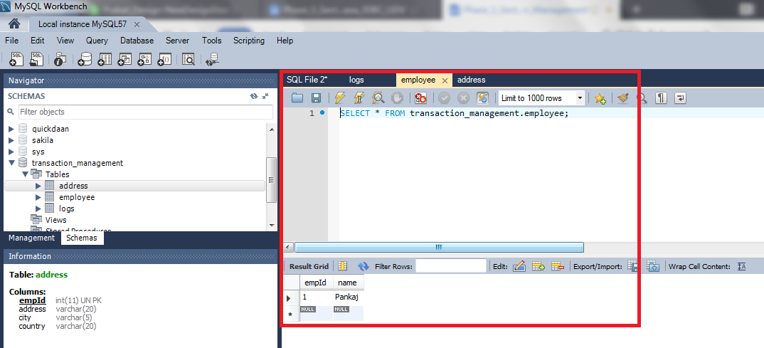

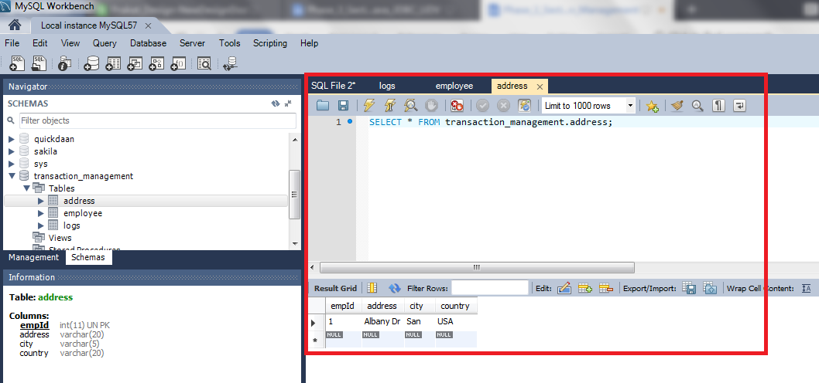

* Notice that connection is committed only when both the inserts are executed successfully. If any of them throws an exception, we are rolling back the complete transaction.

**Step 3.6.3:** Pushing the code to your GitHub repositories

Open your command prompt and navigate to the folder where you have created your files

cd <folder path>

Initialize your repository using the following command:

git init

Add all the files to your git repository using the following command:

git add .

Commit the changes using the following command:

git commit . -m “Changes have been committed.”

Push the files to the folder you initially created using the following command:

git push -u origin master